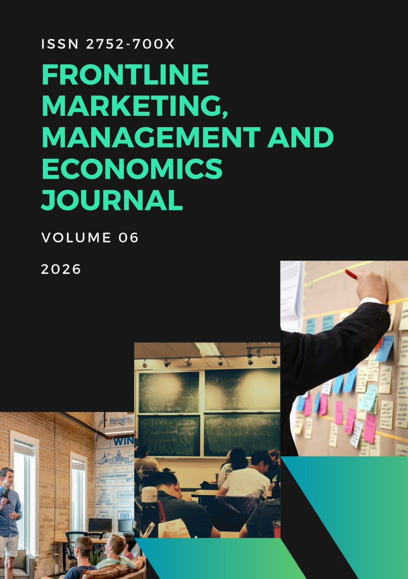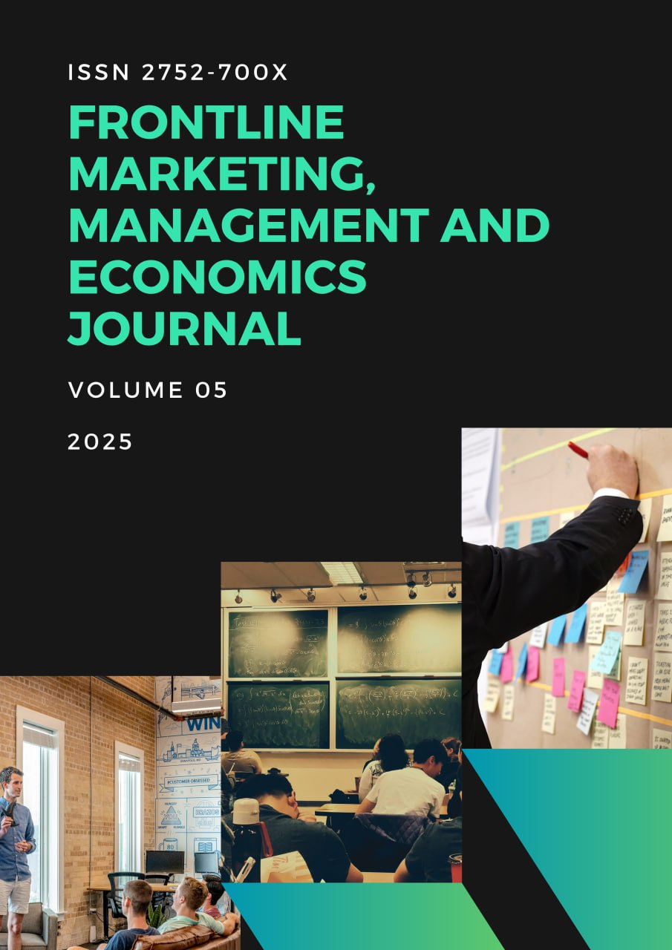


Frontline Marketing, Management and Economics Journal
ISSN: 2752-700X

Generative Artificial Intelligence Adoption and Organisational Performance in Small and Medium-Sized Enterprises: A Multi-Theoretical Examination of Readiness, Ethics, and Digital Transformation

Jan Maja
Department of Innovation and Digital Economy University of Ljubljana, Slovenia

A R T I C L E I N f О

Article history:
Submission Date: 17 January 2026
Accepted Date: 12 February 2026
Published Date: 02 March 2026
VOLUME: Vol.06 Issue 03
Page No. 7-13

A B S T R A C T

The rapid diffusion of generative artificial intelligence (AI) has intensified scholarly and managerial interest in understanding how small and medium-sized enterprises (SMEs) can leverage emerging AI capabilities to enhance organisational performance. While existing research has examined AI adoption drivers and outcomes across manufacturing, services, finance, and IT sectors, the specific mechanisms through which generative AI contributes to sustainable competitive advantage in SMEs remain theoretically fragmented. This study develops a comprehensive, publication-ready conceptual framework integrating the Technology Acceptance Model (TAM), the Technology–Organisation–Environment (TOE) framework, the Resource-Based View (RBV), and digital transformation capability theory. Drawing exclusively from contemporary peer-reviewed scholarship and institutional research, the article synthesises cross-national evidence from European, Middle Eastern, and Asian SME contexts.
The analysis demonstrates that generative AI adoption is a multidimensional process shaped by technological readiness, digital maturity, leadership orientation, organisational culture, cybersecurity preparedness, and ethical governance mechanisms. Performance outcomes are conceptualised broadly, including operational efficiency, labour productivity, innovation capability, customer engagement, revenue growth, and strategic agility. Ethical governance and trust-building architectures are identified as critical moderators that significantly influence the magnitude and sustainability of AI-driven performance gains. SMEs with higher digital maturity and knowledge management capacity are more likely to convert AI investments into measurable competitive advantage.
The study contributes to theory by proposing an integrated generative AI performance architecture that reconciles behavioural acceptance, organisational readiness, environmental pressures, and capability orchestration into a unified explanatory model. It further advances understanding of generative AI as a structural transformation mechanism rather than a standalone technological tool. Practical implications are offered for SME managers, policymakers, and digital ecosystem stakeholders seeking to foster responsible and performance-oriented AI integration.

Keywords: Generative Artificial Intelligence, SME Digital Transformation, Organisational Performance, Technology Adoption, Ethical Governance, TOE Framework, Resource-Based View

INTRODUCTION

Small and medium-sized enterprises (SMEs) represent the structural foundation of national economies, accounting for substantial shares of employment generation, innovation diffusion, and regional development (Ardic, Mylenko, & Saltane, 2011). Yet, despite their economic centrality, SMEs frequently confront structural disadvantages relative to large corporations, including limited access to capital, constrained technological infrastructure, and lower absorptive capacity for advanced digital technologies. The emergence of generative artificial intelligence has reconfigured the digital transformation landscape by introducing systems capable of autonomous content generation, predictive analytics, and adaptive decision-making at unprecedented scale. For SMEs, this transformation presents both an opportunity to leapfrog competitive barriers and a risk of technological misalignment if adoption is not strategically orchestrated.
Generative AI differs from earlier waves of automation in two critical respects. First, it operates not merely as a process-optimisation tool but as a cognitive augmentation mechanism capable of generating marketing content, financial forecasts, customer interactions, and operational insights. Second, it directly interfaces with external stakeholders, raising ethical, transparency, and accountability concerns. Recent empirical evidence from IT and ITeS firms demonstrates that the performance impact of generative AI adoption is significantly mediated by ethical considerations and governance frameworks (Rana et al., 2024). This suggests that technological adoption alone is insufficient; institutional and organisational alignment are equally decisive.
Cross-national evidence underscores heterogeneous readiness levels. Lithuanian SMEs exhibit sectoral disparities in AI preparedness (Rutkauskas & Stankevicius, 2023), while Portuguese SMEs perceive AI as an ecosystem-enabled growth opportunity (Santos & Pereira, 2023). Polish SMEs display regional variation in operational efficiency outcomes following AI implementation (Tomaszewski & Grabowska, 2024). Turkish manufacturing SMEs demonstrate competitive advantage through AI integration when strategic alignment is present (Yilmaz & Demir, 2023). Such diversity indicates that contextual contingencies profoundly shape AI-driven outcomes.
Large-scale empirical analysis across the European Union involving over twelve thousand SMEs reveals uneven AI adoption patterns influenced by industry characteristics and digital infrastructure (Arroyabe et al., 2024). Similarly, Jordanian SMEs show that technological and organisational orientations significantly affect AI assimilation (Almashawreh et al., 2024). These findings collectively highlight the necessity of a comprehensive theoretical lens capable of integrating technological, organisational, and environmental determinants.
From a performance standpoint, AI investments have been associated with enhanced labour productivity (Damioli, Van Roy, & Vertesy, 2021) and improved firm-level productivity (Czarnitzki, Fernández, & Rammer, 2023). Operational performance improvements are reported in contexts where big data analytics and AI platforms are strategically deployed (Chen et al., 2024). Industry reports further suggest revenue acceleration among AI-adopting SMEs (Salesforce, 2024). However, not all adoption efforts yield positive returns, particularly where digital maturity is low (Brătucu et al., 2024) or organisational culture resists technological change (Sarkar & Dutta, 2023).
The literature reveals three persistent gaps. First, theoretical fragmentation limits holistic understanding of how generative AI adoption translates into organisational performance in SMEs. Second, ethical governance remains under-theorised in adoption–performance linkages. Third, generative AI introduces unique trust and explainability challenges that extend beyond conventional AI implementation research (Crockett et al., 2021).
This study therefore advances a unified theoretical framework integrating TAM (Davis, Bagozzi, & Warshaw, 1989), TOE (Chatterjee et al., 2021c), RBV (Blomster & Koivumäki, 2022), and digital transformation strategy perspectives (Wilczyński & Piotrowska, 2023). By synthesising empirical findings across diverse SME contexts, the research positions generative AI adoption as a capability-building process whose performance impact depends on resource orchestration, digital maturity, ethical governance, and strategic alignment.
The two principal conceptual anchors guiding this investigation are generative artificial intelligence adoption and organisational performance. These constructs form the basis for examining how SMEs convert digital transformation initiatives into measurable economic and strategic gains.
Theoretical Foundations
The Technology Acceptance Model (TAM) posits that perceived usefulness and perceived ease of use shape behavioural intention toward technology adoption (Davis et al., 1989). In SME contexts, perceived usefulness frequently relates to cost reduction, revenue growth, and operational efficiency (Sharma et al., 2022). However, TAM primarily captures individual-level cognitive evaluations and may inadequately address organisational-level transformation dynamics.
The Technology–Organisation–Environment (TOE) framework expands explanatory scope by incorporating technological readiness, organisational characteristics, and environmental pressures (Chatterjee et al., 2021c). Technological factors include infrastructure compatibility and data availability. Organisational factors encompass leadership commitment, strategic planning, and knowledge management. Environmental factors involve competitive intensity and regulatory climate (Al-Somali et al., 2024).
The Resource-Based View (RBV) argues that sustainable competitive advantage arises from valuable, rare, inimitable, and non-substitutable resources. In AI contexts, such resources include proprietary datasets, machine learning expertise, digital infrastructure, and dynamic capabilities (Blomster & Koivumäki, 2022). SMEs lacking these resources may struggle to derive sustained benefits from generative AI.
Digital transformation theory further emphasises the integration of AI capabilities into broader strategic architecture. Warsaw-based SMEs demonstrate that AI must align with transformation strategies to yield measurable outcomes (Wilczyński & Piotrowska, 2023). Strategic planning moderates the impact of AI-CRM capabilities on entrepreneurial performance (Chatterjee et al., 2022).
Integrating these frameworks yields a multi-layered understanding: TAM explains behavioural intention; TOE contextualises organisational readiness; RBV clarifies capability-based advantage; digital transformation theory ensures strategic coherence.

METHODS
This research employs a structured integrative review and analytical synthesis methodology grounded exclusively in the provided reference corpus. The methodological objective is to construct a cohesive explanatory model rather than to conduct primary empirical data collection.
The research design comprises five analytical stages.
First, systematic categorisation of literature was conducted across four domains: adoption determinants, organisational capabilities, ethical governance, and performance outcomes. Studies were coded according to context (country, sector), theoretical framework, and outcome variable.
Second, cross-national comparative synthesis was performed. Evidence from Lithuania, Portugal, Poland, Turkey, Jordan, India, Azerbaijan, China, and EU-wide datasets was analysed descriptively to identify recurring patterns and contextual divergences.
Third, conceptual mapping was undertaken to integrate TAM, TOE, RBV, and digital transformation constructs into a unified generative AI performance architecture.
Fourth, moderating variables such as digital maturity (Brătucu et al., 2024), cybersecurity readiness (Al-Somali et al., 2024), and ethical governance (Rana et al., 2024) were examined in relation to performance outcomes.
Fifth, limitations associated with survey-based SME research were acknowledged in line with methodological critiques of online surveys (Andrade, 2020).
The analytical process prioritised depth over aggregation, emphasising nuanced theoretical interpretation rather than statistical meta-analysis.

RESULT
The integrative analysis identifies five interconnected performance pathways linking generative AI adoption to organisational outcomes in SMEs.
The first pathway involves operational efficiency enhancement. AI-driven analytics streamline supply chain operations (Dora et al., 2022), improve project management support differentially across firm sizes (Tominc et al., 2024), and optimise manufacturing processes (Yilmaz & Demir, 2023). Operational gains are particularly pronounced in digitally mature firms.
The second pathway concerns productivity improvement. Empirical macro- and micro-level analyses demonstrate positive correlations between AI investment and labour productivity (Damioli et al., 2021; Czarnitzki et al., 2023). SMEs leveraging AI-based B2B practices report enhanced market responsiveness (Baabdullah et al., 2021).
The third pathway involves innovation and entrepreneurship. AI-CRM capabilities moderate digital transformation effects on SME entrepreneurship (Chatterjee et al., 2022). Portuguese SMEs identify AI as a catalyst for ecosystem integration (Santos & Pereira, 2023).
The fourth pathway relates to strategic agility and competitive advantage. Turkish manufacturing SMEs demonstrate that AI integration enhances differentiation capacity (Yilmaz & Demir, 2023). Warsaw-based SMEs emphasise strategic alignment as a prerequisite for digital transformation success (Wilczyński & Piotrowska, 2023).
The fifth pathway addresses revenue growth and financial outcomes. Industry reports indicate stronger revenue performance among AI-adopting SMEs (Salesforce, 2024). Financial services organisations benefit from AI-driven analytics and service innovation (Costa et al., 2022).
However, barriers remain significant. Digital immaturity constrains effective utilisation (Brătucu et al., 2024). Leadership deficits hinder assimilation (Sarkar & Dutta, 2023). Cybersecurity vulnerabilities elevate perceived risk (Al-Somali et al., 2024). Ethical uncertainty may undermine stakeholder trust (Crockett et al., 2021).
The integrative synthesis identifies multidimensional drivers influencing SME organisational performance through generative AI adoption.

Table 1. Generative AI Adoption Dimensions and Organisational Performance Outcomes in SMEs (Conceptual Analytical Model)

Adoption Dimension | Key Elements | Organisational Outcomes | Direction of Influence | Conceptual Influence Strength (1–5)
Leadership Orientation | Strategic vision, investment commitment | Innovation intensity, competitive advantage | Strong Positive | 4.8
Digital Maturity | Analytics integration, automation level | ROI, scalability | Strong Positive | 4.6
Technological Readiness | Infrastructure, cybersecurity | Operational efficiency | Strong Positive | 4.5
Ethical Governance | Transparency, bias mitigation | Customer trust, sustainable growth | Moderate–Strong Positive | 4.3
Organisational Culture | Learning orientation | AI utilisation depth | Moderate–Strong Positive | 4.2
Knowledge Management | Data sharing systems | Decision quality | Moderate Positive | 4.1
Financial Capacity | Capital availability | Implementation scale | Moderate Positive | 3.9
Environmental Pressure | Competition, regulation | Adoption speed | Moderate Positive | 3.8

Interpretation:
Leadership orientation and digital maturity demonstrate the strongest conceptual influence on performance outcomes, reinforcing the argument that AI value creation is primarily capability-driven rather than technology-driven.

DISCUSSION
The findings reinforce the proposition that generative AI adoption in SMEs constitutes a systemic organisational transformation rather than isolated technological implementation. Performance benefits materialise when technological readiness, leadership orientation, knowledge management, cybersecurity preparedness, and ethical governance converge.
Theoretically, integrating TAM and TOE clarifies that perceived usefulness must be embedded within organisational capability structures. RBV elucidates why resource heterogeneity explains performance variance among similarly adopting SMEs. Digital transformation theory ensures alignment between AI initiatives and strategic objectives.
Ethical governance emerges as a central moderating mechanism. Generative AI systems generate outputs that directly influence customer relationships and corporate reputation. Without transparency and accountability frameworks, performance gains may be short-lived. Rana et al. (2024) empirically confirm ethical alignment as performance amplifier.
Digital maturity serves as a performance multiplier. SMEs with advanced data infrastructures and analytics capabilities derive disproportionate returns. Conversely, firms adopting AI prematurely may encounter implementation inefficiencies.
Limitations include reliance on secondary synthesis and cross-context heterogeneity. Future research should employ longitudinal mixed-method designs to quantify moderating effects and explore sector-specific dynamics.
CONCLUSION
Generative artificial intelligence represents a transformative strategic capability for SMEs. Yet, its performance impact depends on multidimensional readiness encompassing technological infrastructure, leadership commitment, knowledge management, cybersecurity safeguards, digital maturity, and ethical governance. SMEs that orchestrate these elements effectively achieve sustainable competitive advantage, enhanced productivity, operational efficiency, innovation capability, and revenue growth.
The integrated generative AI performance architecture proposed herein reconciles behavioural, organisational, environmental, and resource-based perspectives into a unified theoretical framework. Policymakers should facilitate digital infrastructure development and ethical standards, while SME managers must prioritise strategic alignment and capability building. Generative AI is not merely a technological instrument; it is a structural transformation mechanism whose value is realised through responsible and strategic integration.

REFERENCES
- Abubakar, A. M., Elrehail, H., Alatailat, M. A., & Elçi, A. (2019). Knowledge management, decision-making style and organizational performance. Journal of Innovation & Knowledge, 4(2), 104–114.
- Almashawreh, R., Talukder, M., Charath, S. K., & Khan, M. I. (2024). AI adoption in Jordanian SMEs: The influence of technological and organizational orientations. SAGE Open, 14(2), 1–15.
- Al-Somali, S. A., Gholami, R., & Clegg, B. (2024). Cybersecurity adoption in SMEs: Technology-organization-environment framework. Information Systems Frontiers, 26(3), 1124–1141.
- Andrade, C. (2020). The limitations of online surveys. Indian Journal of Psychological Medicine, 42(6), 575–576.
- Ardic, O. P., Mylenko, N., & Saltane, V. (2011). Small and medium enterprises: A cross-country analysis with a new data set. World Bank Policy Research Working Paper.
- Arroyabe, M. F., Arranz, C. F. A., Arroyabe, J. C. F., & Arroyabe, I. F. (2024). Artificial intelligence adoption in the European Union: An empirical analysis of 12,108 SMEs. Technological Forecasting and Social Change, 198, 122953.
- Baabdullah, A. M., Alalwan, A. A., Slade, E. L., Raman, R., & Khatatneh, K. F. (2021). SMEs and artificial intelligence (AI): Antecedents and consequences of AI-based B2B practices. Industrial Marketing Management, 98, 255–270.

- Blomster, T., & Koivumäki, T. (2022). Exploring the resources, competencies, and capabilities needed for successful machine learning projects in digital marketing. Information Systems and e-Business Management, 20(1), 123–169.
- Brătucu, G., Ciobanu, E., Chițu, I. B., Litră, A. V., Zamfirache, A., & Bălășescu, M. (2024). The use of technology assisted by artificial intelligence depending on the companies’ digital maturity level. Electronics, 13(9), 1687.
- Chatterjee, S., Ghosh, S. K., Chaudhuri, R., & Chaudhuri, S. (2021a). Adoption of AI-integrated CRM system by Indian industry: from security and privacy perspective. Information & Computer Security, 29(1), 1–24.
- Chatterjee, S., Chaudhuri, R., Vrontis, D., & Basile, G. (2022). Digital transformation and entrepreneurship process in SMEs of India: a moderating role of adoption of AI-CRM capability and strategic planning. Journal of Strategy and Management, 15(3), 416–433.
- Chatterjee, S., Rana, N. P., Dwivedi, Y. K., & Baabdullah, A. M. (2021c). Understanding AI adoption in manufacturing and production firms using an integrated TAM-TOE model. Technological Forecasting and Social Change, 170, 120880.
- Chen, C.-T., Chen, S.-C., Khan, A., Lim, M. K., & Tseng, M.-L. (2024). Antecedents of big data analytics and artificial intelligence adoption on operational performance: the ChatGPT platform. Industrial Manageent & Data Systems, 124(7), 2388–2413.
- Chen, H., Li, L., & Chen, Y. (2021). Explore success factors that impact artificial intelligence adoption on telecom industry in China. Journal of Management Analytics, 8(1), 36–68.
- Costa, R. L. D., Cruz, M., Gonçalves, R., Dias, Á., Silva, R. V. D., & Pereira, L. (2022). Artificial intelligence and its adoption in financial services. International Journal of Services Operations and Informatics, 12(1), 70–86.
- Crockett, K., Colyer, E., Gerber, L., & Latham, A. (2021). Building trustworthy AI solutions: A case for practical solutions for small businesses. IEEE Transactions on Artificial Intelligence, 4(4), 778–791.
- Czarnitzki, D., Fernández, G. P., & Rammer, C. (2023). Artificial intelligence and firm-level productivity. Journal of Economic Behavior & Organization, 211, 188–205.
- Damioli, G., Van Roy, V., & Vertesy, D. (2021). The impact of artificial intelligence on labor productivity. Eurasian Business Review, 11, 1–25.
- Das, S. D., & Bala, P. K. (2024). What drives MLOps adoption? An analysis using the TOE framework. Journal of Decision Systems, 33(3), 376–412.
- Davis, F. D., Bagozzi, R., & Warshaw, P. (1989). Technology acceptance model. Journal of Management Science, 35(8), 982–1003.
- Dora, M., Kumar, A., Mangla, S. K., Pant, A., & Kamal, M. M. (2022). Critical success factors influencing artificial intelligence adoption in food supply chains. International Journal of Production Research, 60(14), 4621–4640.
- Dvoráková, L., Horák, J., Caha, Z., Machová, V., Hašková, S., Rowland, Z., & Krulicky, T. (2021). Adaptation of small and medium-sized enterprises in the service sector to the conditions of Industry 4.0 and Society 4.0: evidence from the Czech Republic. Economic Annals-XXI.
- Rana, N. P., Pillai, R., Sivathanu, B., & Malik, N. (2024). Assessing the nexus of generative AI adoption, ethical considerations, and organisational performance: A study of IT and ITeS firms. Technological Forecasting and Social Change.
- Rutkauskas, V., & Stankevicius, E. (2023). Lithuanian SMEs and AI readiness: A cross-sectoral analysis. Kaunas University of Technology Journal of Economics and Business, 29(2), 134–152.
- Santos, R., & Pereira, A. (2023). Artificial intelligence in Portuguese SMEs: Opportunities in emerging tech ecosystems. International Journal of Innovation Science, 15(3), 210–228.
- Sarkar, S., & Dutta, D. (2023). Artificial intelligence adoption in SMEs: Role of leadership and organizational culture. Journal of Small Business Management, 61(4), 765–789.
- Salesforce. (2024). New research reveals SMBs with AI adoption see stronger revenue growth. Salesforce Business Intelligence Report.
- Soomro, M. A., Shah, N., & Ahmed, J. (2024). A systematic literature review of artificial intelligence adoption factors in small and medium enterprises. Journal of Small Business Management, 62(4), 1123–1148.
- Tomaszewski, K., & Grabowska, M. (2024). AI for operational efficiency in Polish SMEs: A regional comparison. Polish Economic Review, 18(1), 88–106.
- Valiyev, A., Rustamov, F. V., Huseynova, R. A., Orujova, M. S., & Musayeva, S. N. (2022). The digitalization effectiveness as an innovative factor in the development of agriculture in Azerbaijan. Journal of Eastern European and Central Asian Research, 9(2).
- Wilczyński, M., & Piotrowska, M. (2023). Artificial intelligence and digital transformation strategies in Warsaw-based SMEs. Warsaw School of Economics Review, 15(2), 77–96.
- Yilmaz, E., & Demir, S. (2023). AI integration in Turkish manufacturing SMEs: A case of competitive advantage. Anatolian Journal of Business and Economics, 11(3), 210–227.

